Git ASSIGNMENT : 4 :

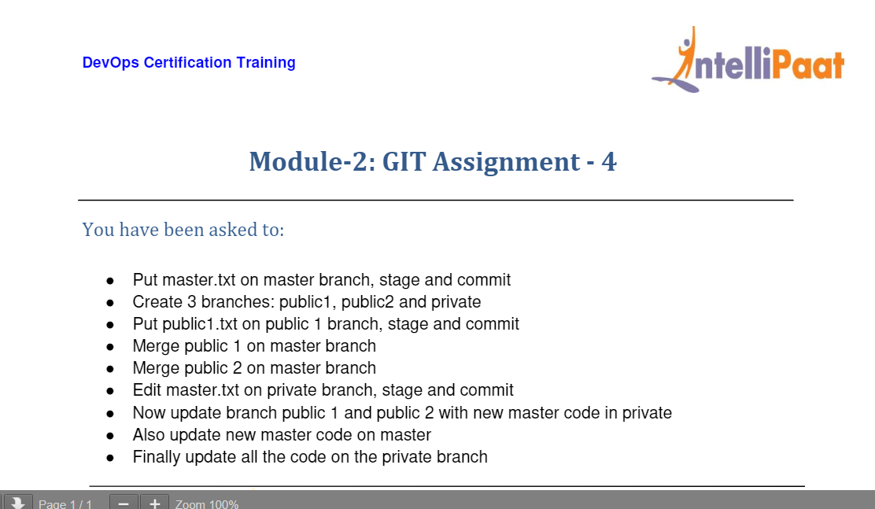

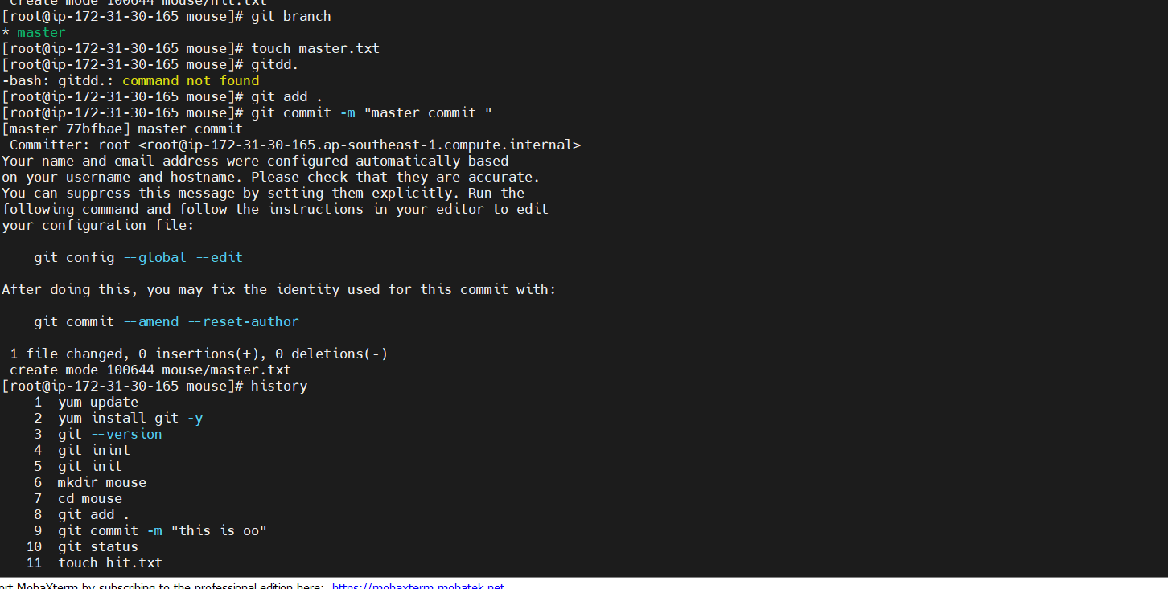

1 yum update

2 yum install git -y

3 git --version

4 git inint

5 git init

6 mkdir mouse

7 cd mouse

8 git add .

9 git commit -m "this is oo"

10 git status

11 touch hit.txt

12 git add .

13 git commit -m "Kkkk"

14 git branch

15 touch master.txt

16 gitdd.

17 git add .

18 git commit -m "master commit "

19 history

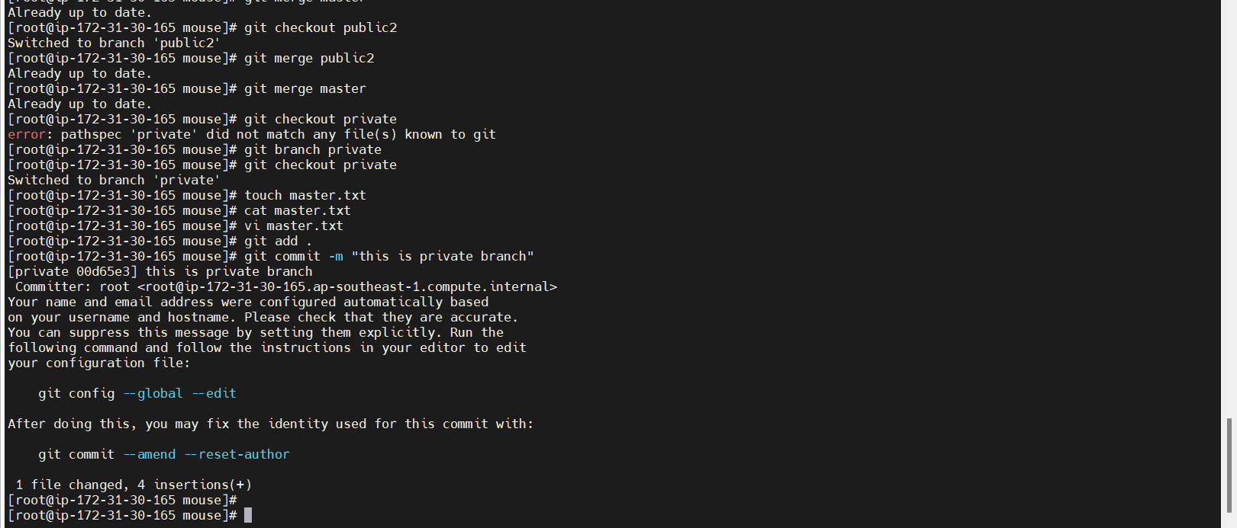

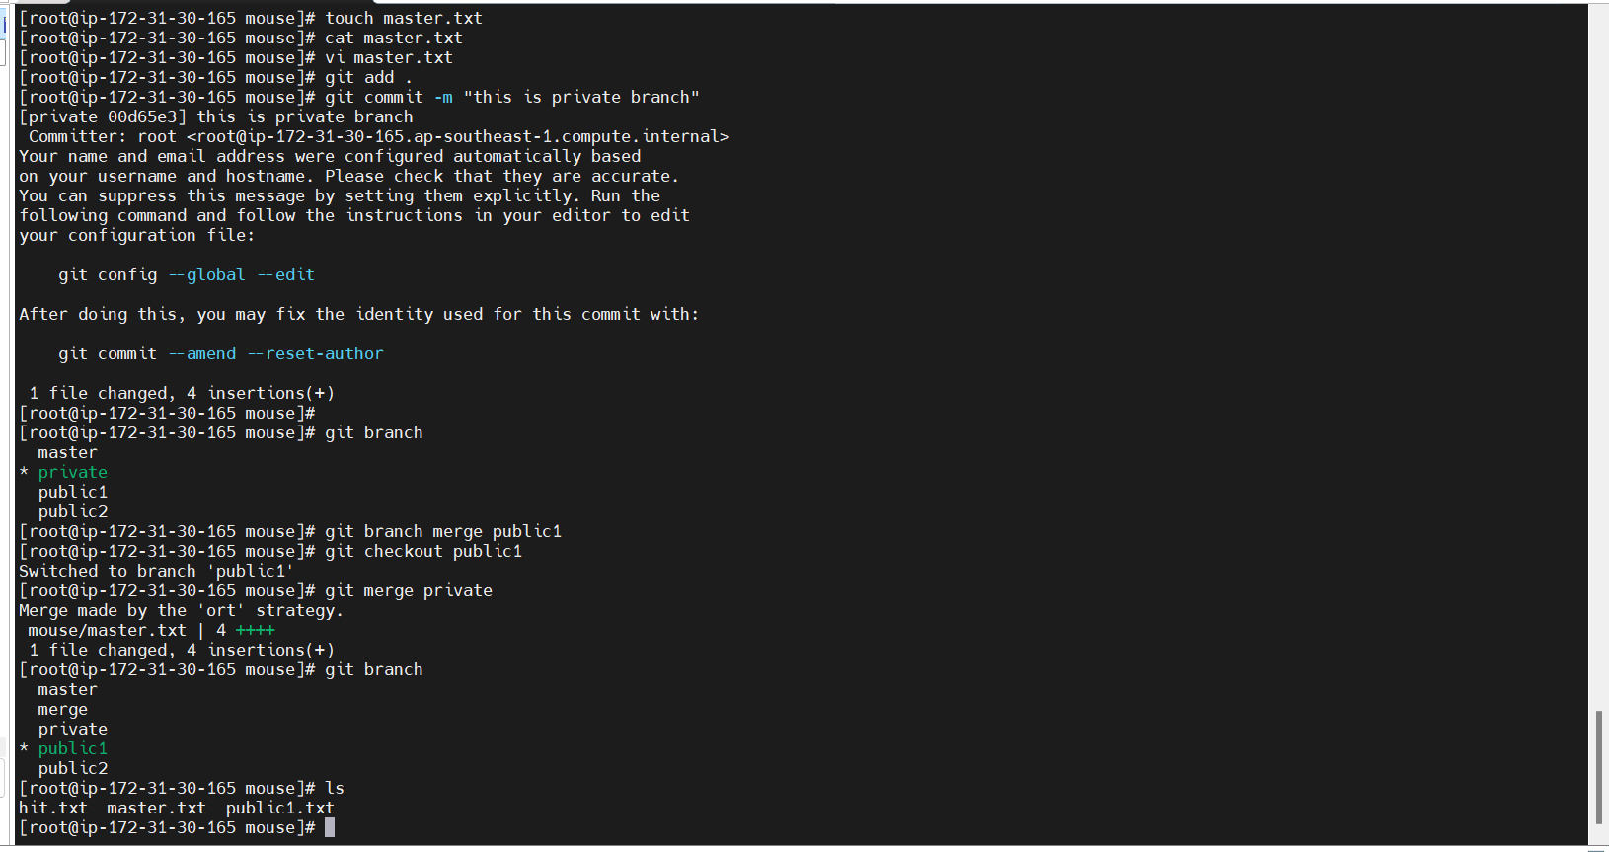

6 mkdir mouse

7 cd mouse

8 git add .

9 git commit -m "this is oo"

10 git status

11 touch hit.txt

12 git add .

13 git commit -m "Kkkk"

14 git branch

15 touch master.txt

16 gitdd.

17 git add .

18 git commit -m "master commit "

19 history

20 git branch public1

21 git branch public2

22 git checkout public1

23 touch public1.txt

24 git add .

25 git commit -m "Public1 commit "

26 git merge master

27 git branch

28 git merge master

29 git checkout public2

30 git merge public2

31 git merge master

32 git checkout private

33 git branch private

34 git checkout private

35 touch master.txt

36 cat master.txt

37 vi master.txt

38 git add .

39 git commit -m "this is private branch"

40 git branch

41 git branch merge public1

42 git checkout public1

43 git merge private

44 git branch

45 ls

46 git checkout public2

47 ls

48 git merge private

49 ls

50 cat master.txt

51 git checkout master

52 ls

53 cat master.txt

54 ls

55 git merge private

56 ls

57 cat master.txt

58 git checkout private

59 ls

60 cat master.txt

61 history

[root@ip-172-31-30-165 mouse]#